Flashback **Technology**

Flashback Technology enables us to recover from user errors without restoring or using backup of the database.

The following are the flashback technology.

1. Flashback Drop (Uses Recycle bin feature)
2. Flashback Table(Uses undo data)
3. Flashback Query( Uses Undo data)
4. Flashback Version Query( Uses undo data)
5. Flashback Transaction Query(Uses undo data)
6. Flashback Database(Uses flashback log/flash recovery area)

------------------------------------------------------------------------------------

Flashback Drop ( New feature in 10g)

This feature enables us to restore table, if any user table is accidentally dropped, without using backup. This feature uses recycle bin. Recyclebin is a new feature of oracle 10g. It is a logical structure (acts like a container) in each locally managed tablespace. It is not present in Dictionary managed tablespace.

To see any objects in recyclebin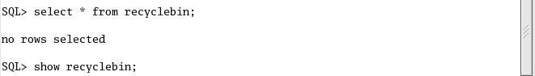

The following example shows that a table is accidentally dropped. In 10g when a table is accidentally dropped , it is not promptly removed from the database, it is still in their user’s schema, but it renamed it , and the original information is strored in the recyclebin of the corresponding tablespace.

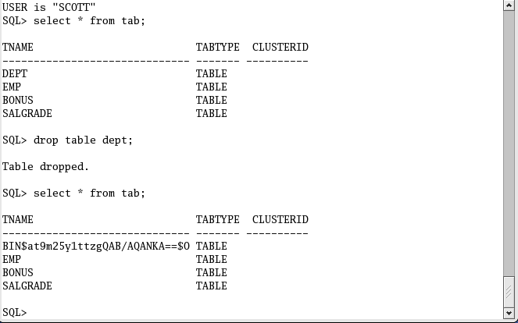

When a table is accidentally dropped, we can restore it from the recyclebin.

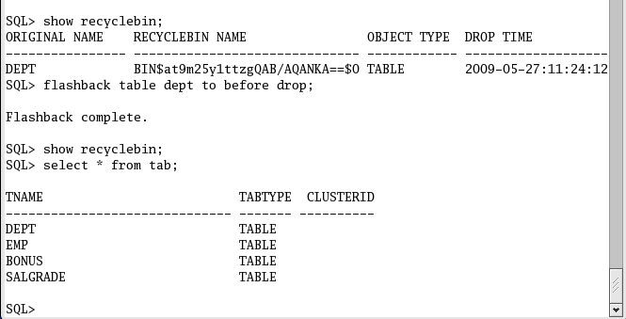

If you want to drop a table permanent ,use purge command with drop command syntax. Once the table is removed with purge command we cannot restore it , we have to depend on backup.

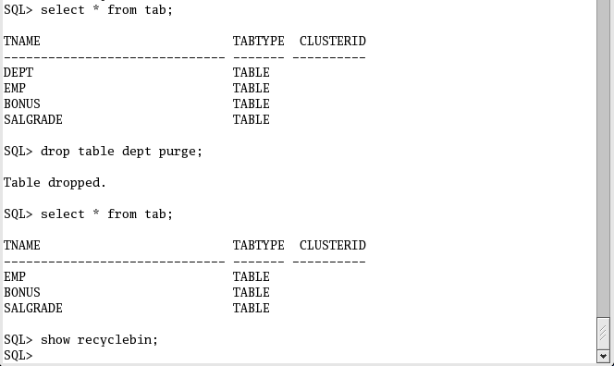

Flashback Table (Uses undo data)

This feature enables us to restore table to a previous point in time or SCN without using any backup.

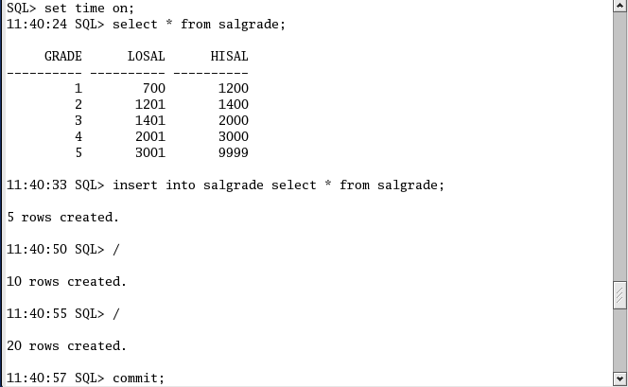

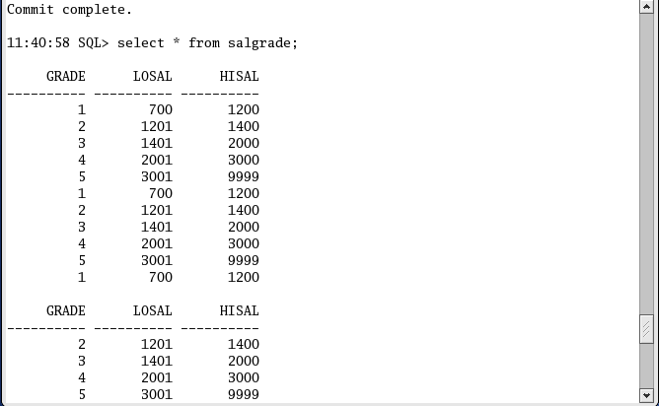

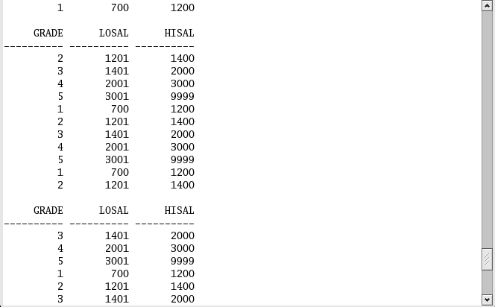

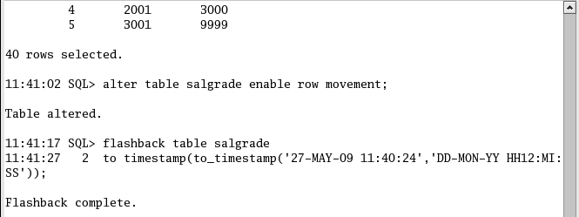

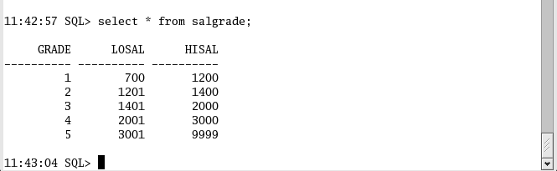

Instead of using timestamp we can also use SCN (System Change Number).

As for example

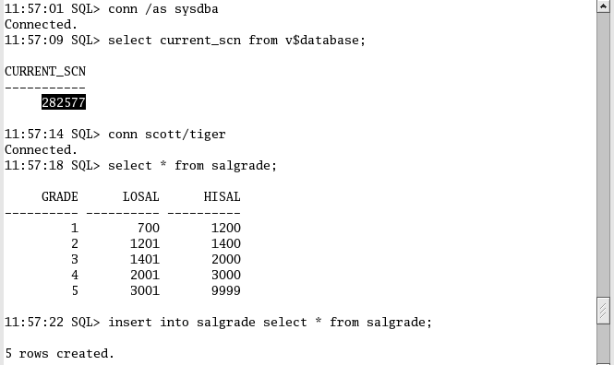

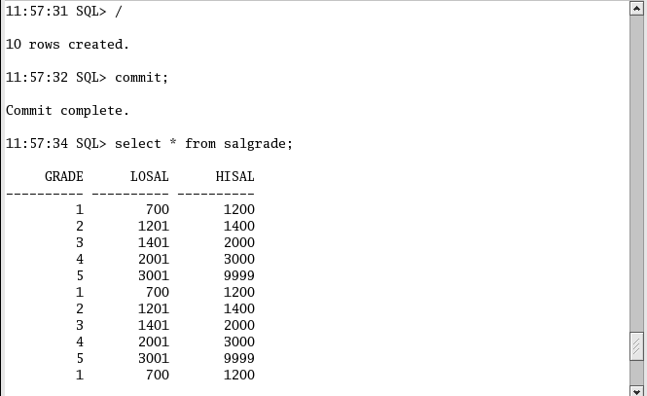

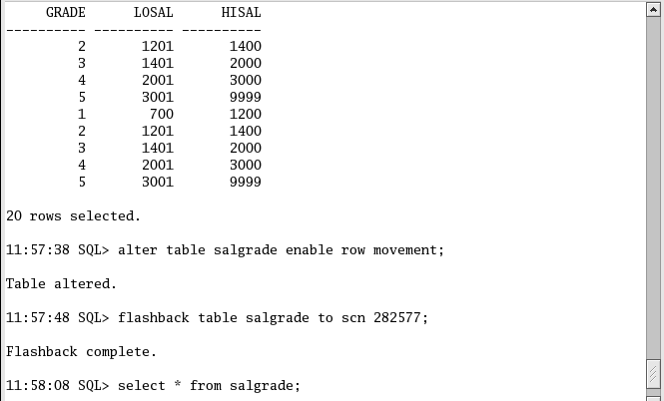

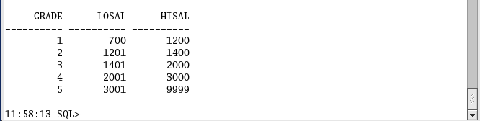

------------------------------------------------------------------------------------

Flashback Query ( Uses Undo data)

Flashback Query enables us to query the table to a previous point in time or SCN. Or we can say that query old data in a table. Flashback query uses undo data in undo tablespace.

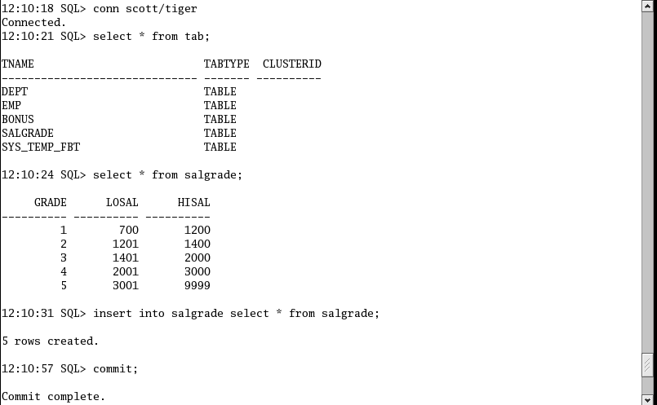

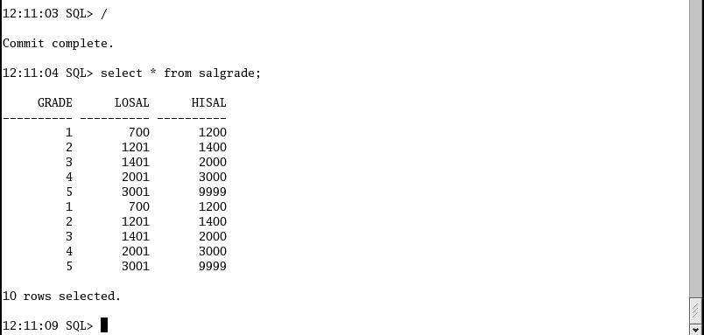

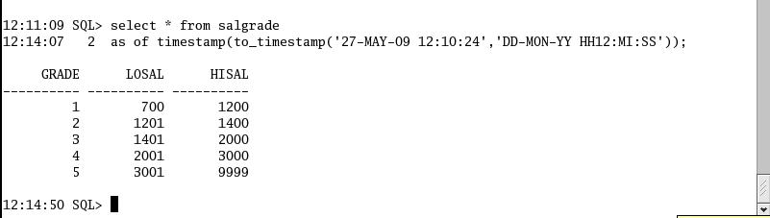

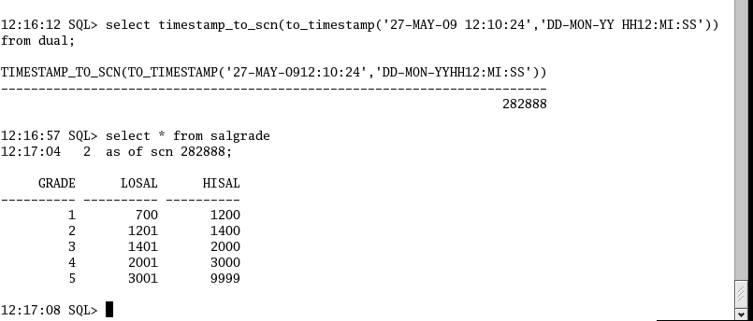

---------------------------------------------------------------------------------

FLASHBACK DATABASE( New feature in 10g)

This features enables us to restore (to rewind) your database to a previous point in time or previous SCN.

To use this feature the database must be

1. Enabled archive log mode.
2. Enabled flash recovery area
3. Must be enabled flashback on

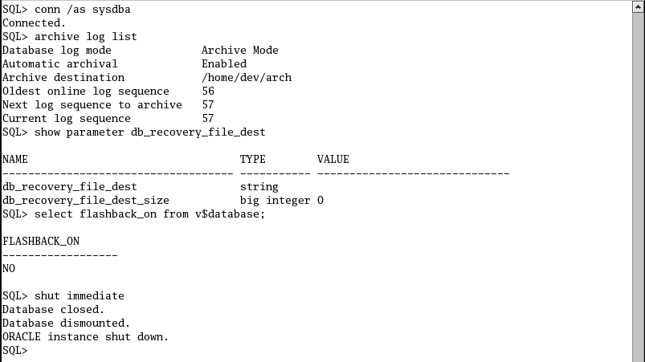

It shows that flash recovery area is not enabled and also flashback_on option is not enabled

How to configure flash recovery area

Open the parameter file and add these parameter



Create appropriate directory

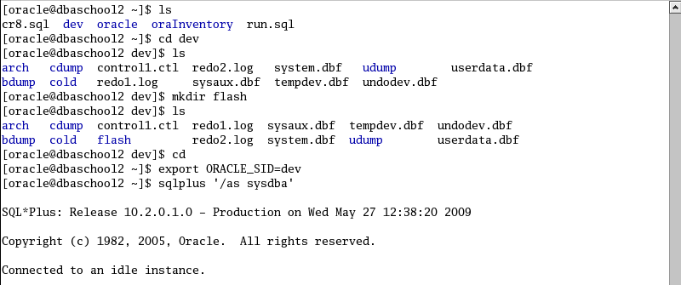

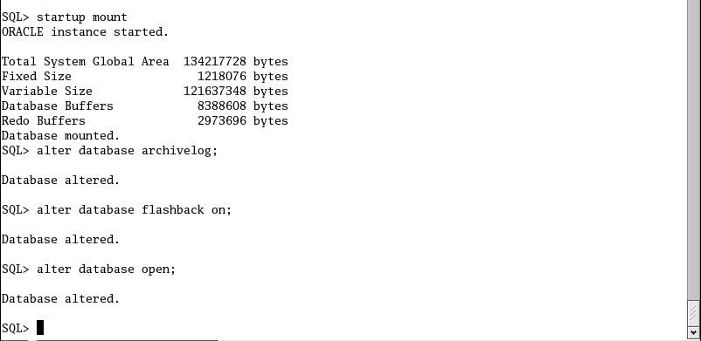

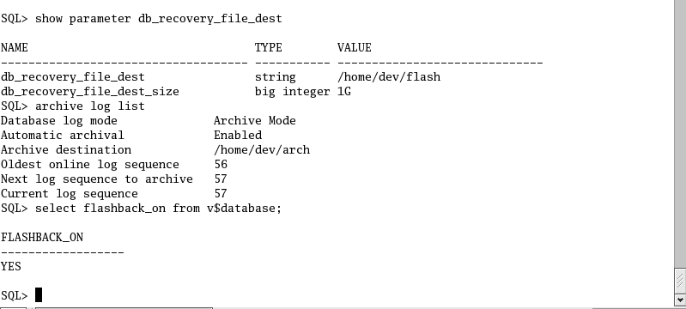

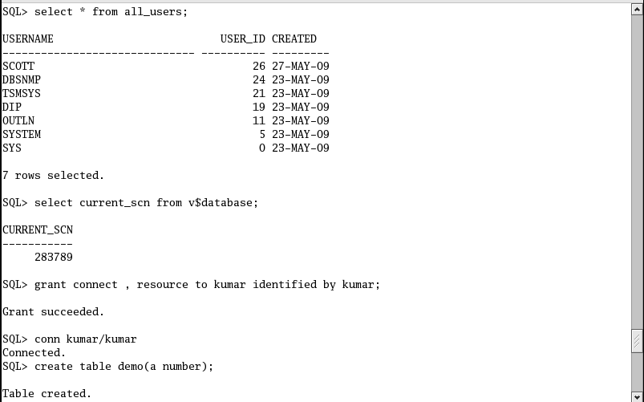

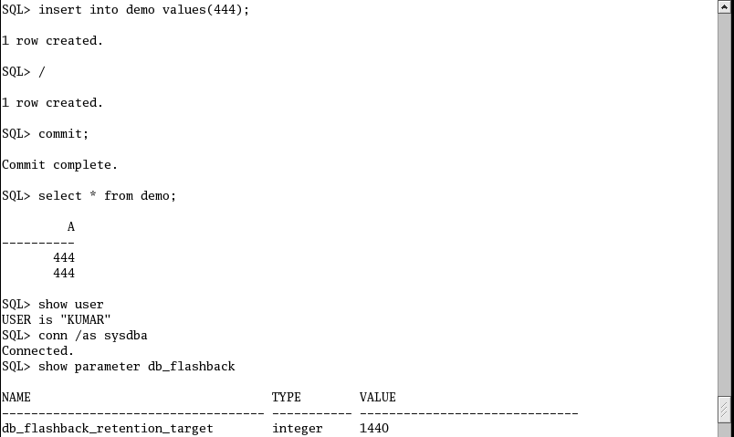

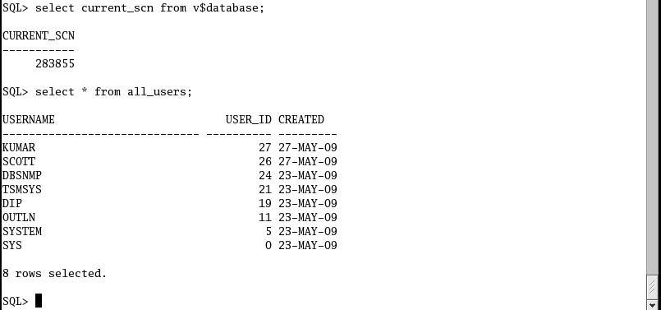

At this stage one user kumar is dropped.

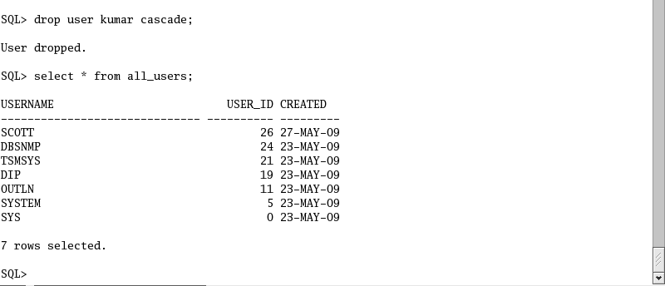

At this stage user kumar is dropped, by using flashback database feature we can restore to a previous point in time

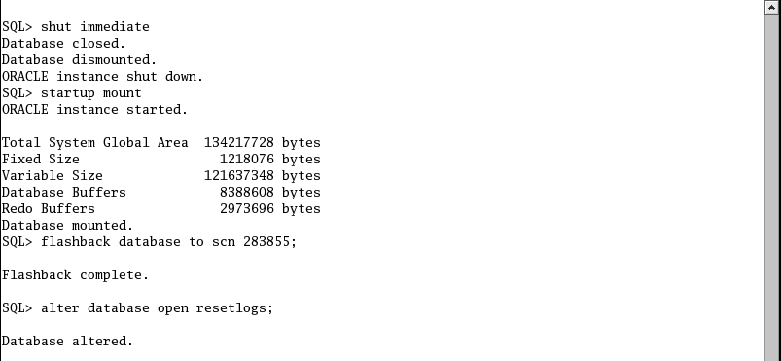

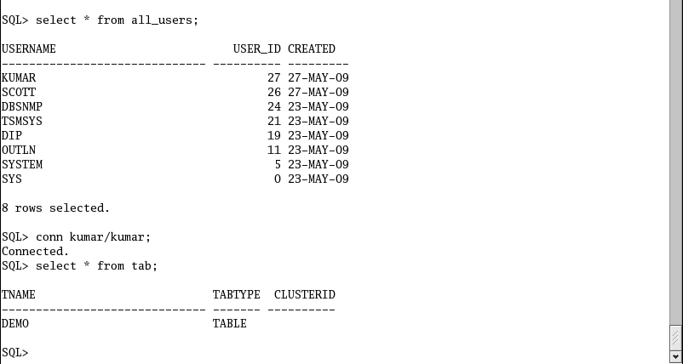

Flashback versions query

It is used to know the row history of a table. It is used to know how many times a particular row has been changed between two timestamp or scn and what are the transactions were responsible for that.

For this the following pseudo column is used

Versions_startscn

Versions_endscn

Versions_operation

Versions_xid

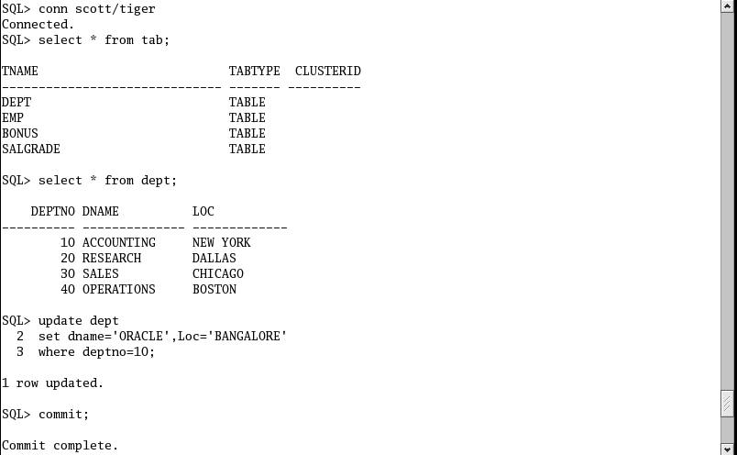

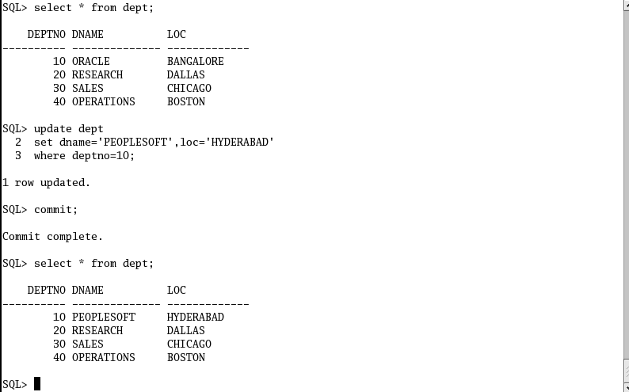

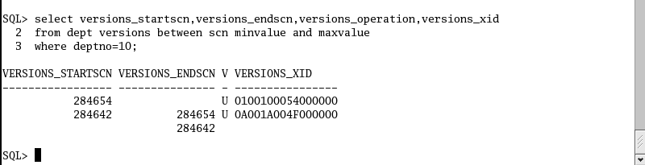

Flashback transacton query

It enables us to know which transactions are responsible for change in the database. It also enables us to find out the exact transactions which you want to undo. The following view is used to

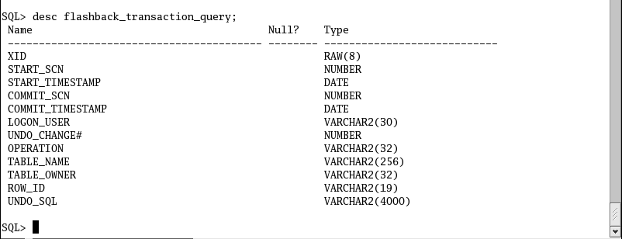

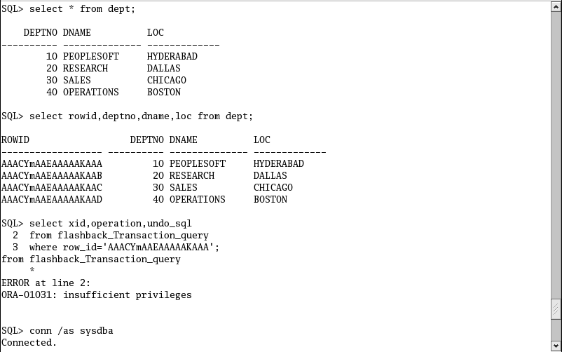

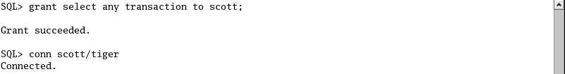



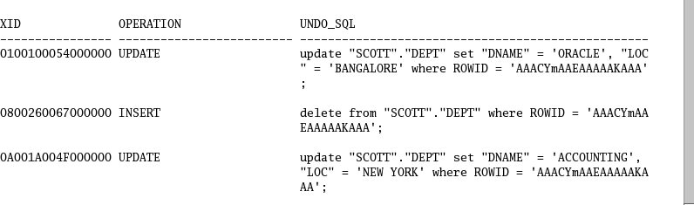

Just identifies the operation, which you want to undo it,

